1. **Problem definition and description**

Data visualization brings insights by curating data into a form easier to understand, highlighting the trends and meaningful outliers. On the first attempt, I defined the project's main purpose as a "useful visualization" for those who reach the information only by the visualized graphs, without the original datasets. Therefore, i) to visualize the characteristics of the dataset effectively and ii) to make the graphs reactive were significantly considered. The first dataset (DailyTemperatureDaejeon.csv) was plotted in deflected line graphs related to time series. Plus, the second dataset (DailyTemperatureStation.csv) was plotted as a geographical 3D bar graph on Google Earth.

In the current second attempt, I reflected my attitude as a researcher away from the user-centered perspective as a producer: the need for deeper insights and detailed analysis has been recognized. Therefore, additional insights that could be calculated by raw data such as monthly daily cross or average temperature has been illustrated.

1. **Core code**

# DailyTemperatureDaejeon.csv: plot by date

daily_temp=go.Scatter(x=date_series, y=daejeon['Daily temperature'], mode='lines', name='Daily', line=dict(color='#0C2141'))

maximum_temp=go.Scatter(x=date_series, y=daejeon['Maximum'],mode='lines',opacity =.8,name='Highest', line=dict(color='#EF5350'))

minimum_temp=go.Scatter(x=date_series,y=daejeon['Minimum'],mode='lines',opacity=.8,name='Lowest',line =dict(color = '#2068B3'))

#calculat monthly daily cross

daejeon_month = daejeon.groupby(pd.Grouper(key='Date  
_exported', freq='M'))['Daily_cross'].mean()

fig2 = go.Figure(data = [daily_cross], layout = layout_2)

# DailyTemperatureStation.csv: 3D Bar Plot

# Categorize by Altitude to put different colours

station['Alt_range']=pd.qcut(station['Altitude (m)'], q = 6)

# Draw Top Circle of the Cylinder Bar Plot

top=Polycircle(latitude=latitude,longitude=longitude,radius=5000,number_of_vertices=36)

# Draw Wall of the Cylinder Bar Plot

bar_wall=[tuple(a_point),tuple(a_point_with_height),tuple(b_point_with_height),tuple(b_point), tuple(a_point)]

wall=bar.newpolygon(altitudemode = 'absolute', outerboundaryis=tuple(bar_wall))

1. **Results and plots**

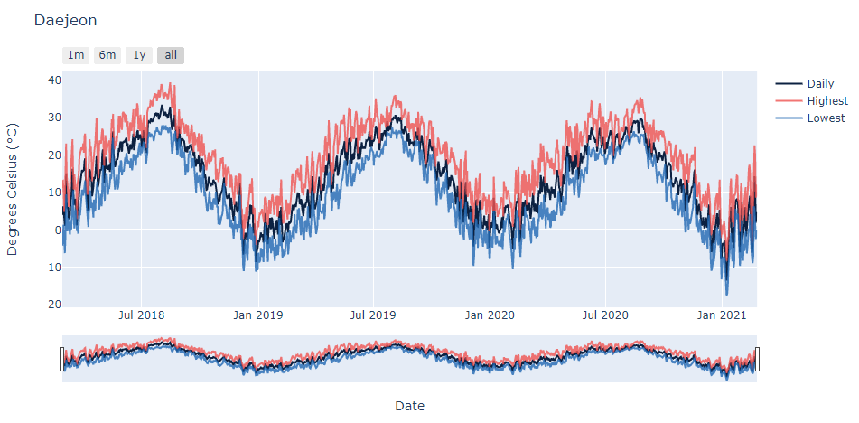

**Figure 1(left). Daily Temperatures of Daejeon**

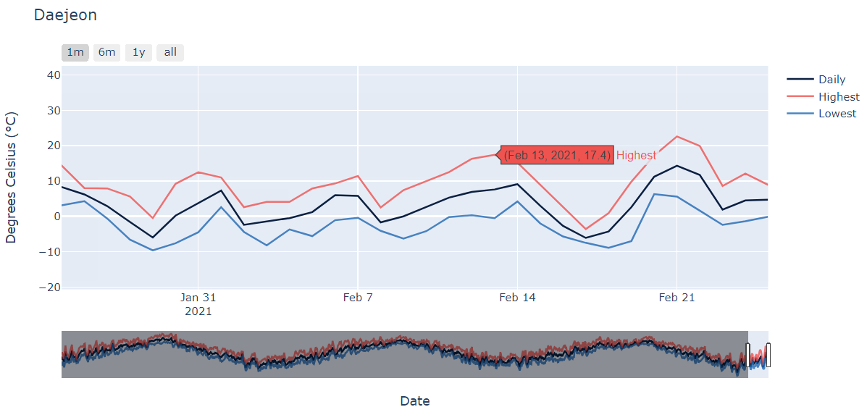 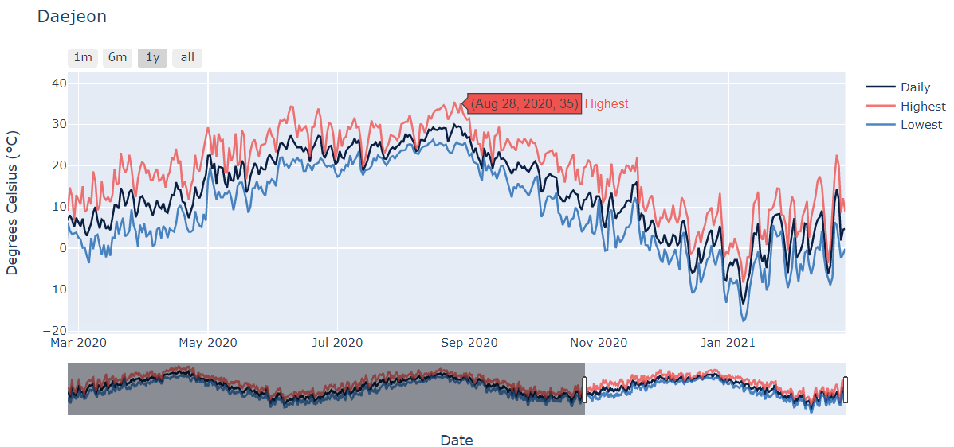

**F­­igure 2. Graphs within time intervals (Buttons)**

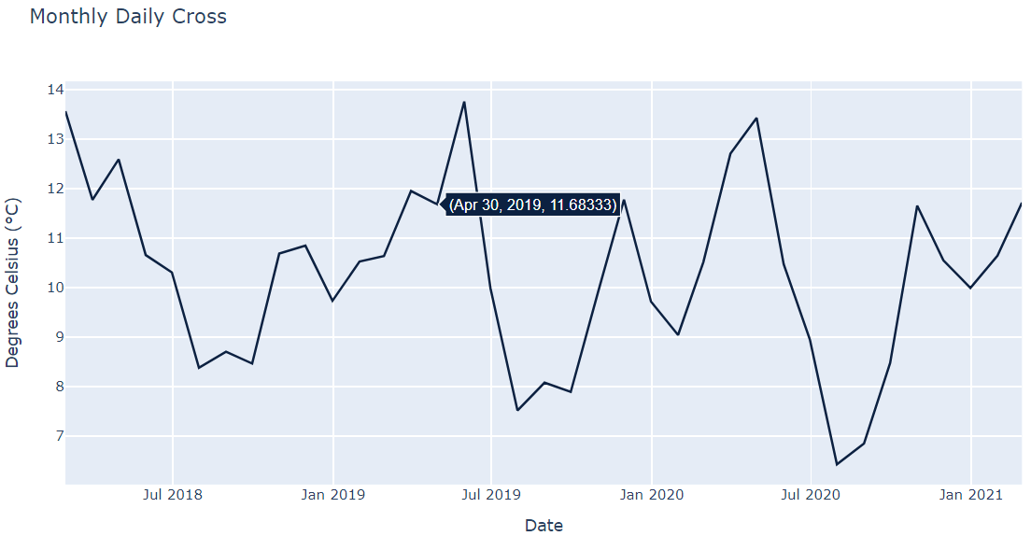

**Figure 3. Monthly Daily cross of Daejeon**

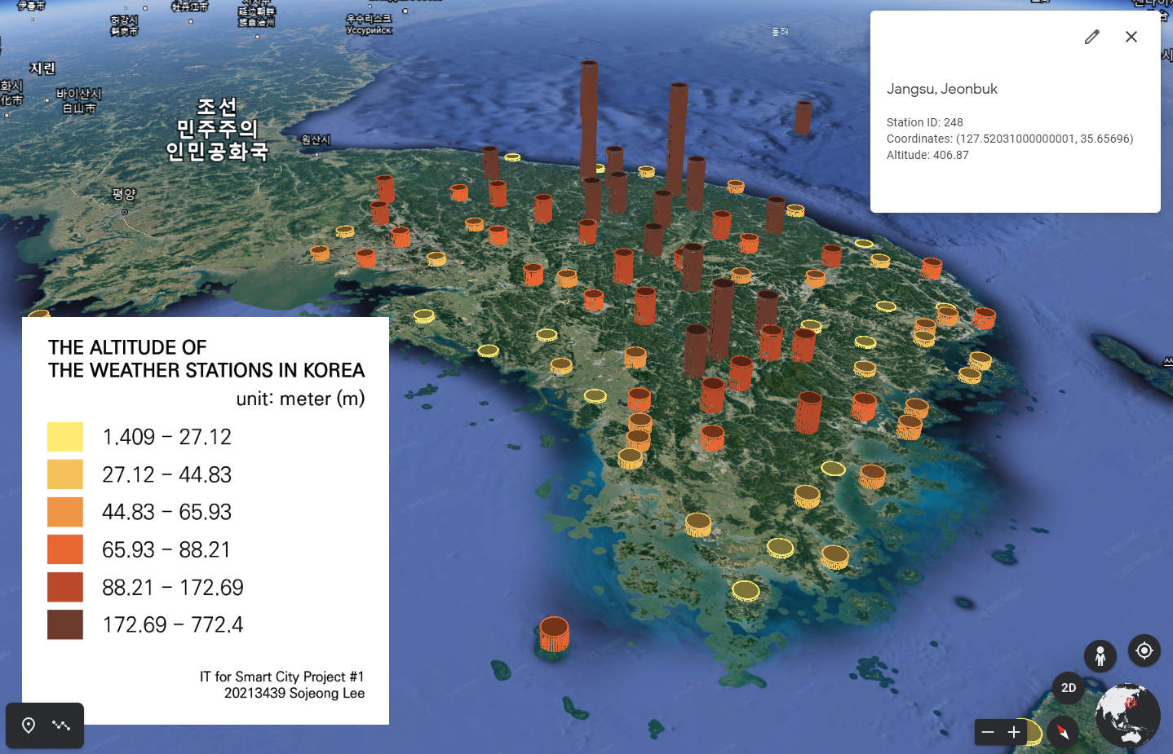

**Figure 4. Daily Temperature Stations (The Altitude of the Weather Stations in Korea)**

1. **Discussion**

Through Figures 1-3, line graphs by times effectively show the temperature changes. Buttons for 1 month, 6 months and 1-year time intervals allow users to expand the graphs more clearly, which could interactively make them come out with the new insights. In Figure 4, the altitude of the weather stations in Korea could be compared easily at a glance by the height of the graph and its colors based on the categorization. This interactive map plotted on Google Earth allows user to navigate on their own, just like the graphs plotted by the library ‘plotly’.

1. **References**